UPPWISE INDIA

www.uppwise.com



**Quaterly Development Planning**

**Q1-2024**

**Feature: Benefit Management AXA (Value Realization)**

**Feature Title:**

Benefit Management AXA (Value Realization)

**Priority:**

Medium

**Submitted By:**

SPM

**Target Users:**

AXA

**Feature Description:**

This feature provides advanced capabilities for seamless migration and efficient management of benefit data. This feature focuses on optimizing the mapping of fields within the Benefit Widget and ensuring accurate migration of benefits with associated values.

**Acceptance Criteria:**

**Benefit Widget Mapping Migration:**

* Ensure the successful migration of field mappings within the Benefit Widget in the SPM.
* Verify that fields such as "Value Realization Title" and "KPI" are accurately mapped and migrated.

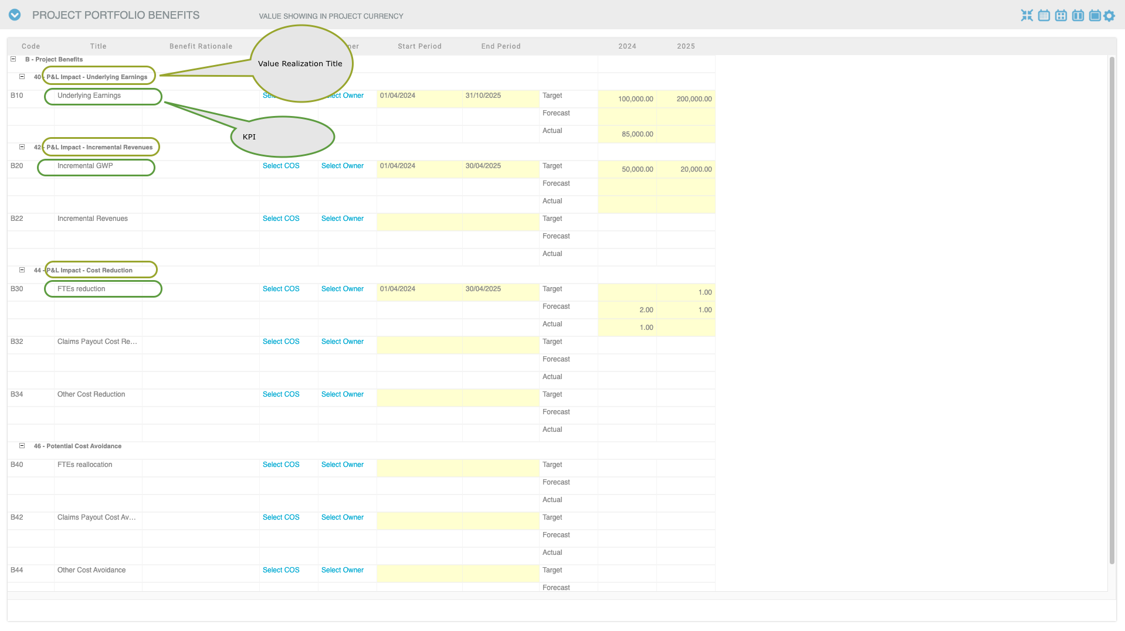

**KPI Configuration Migration:**

* Confirm that all KPIs are migrated with their respective value realizations intact.
* Validate that KPI configurations are accurately transferred to the new system.

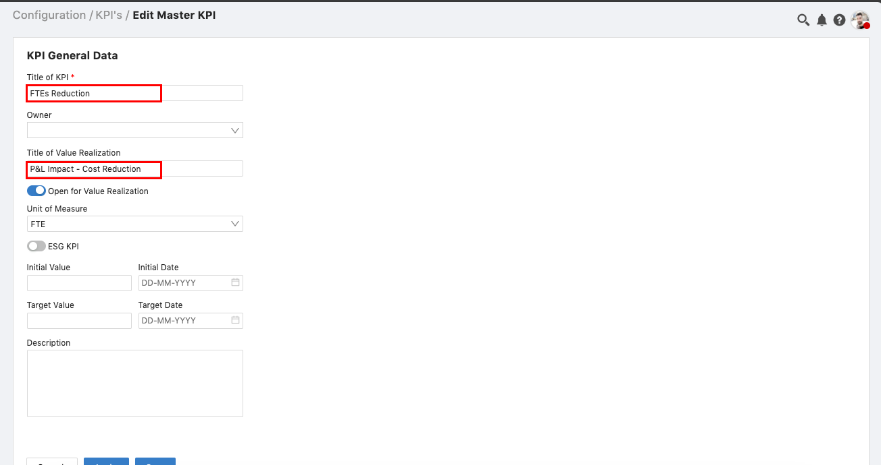

**Benefits Migration with Values:**

* Ensure that only benefits with associated values (e.g., target, actual, forecast) are imported into the SPM.
* Verify that benefits without any associated values are excluded from the migration process.

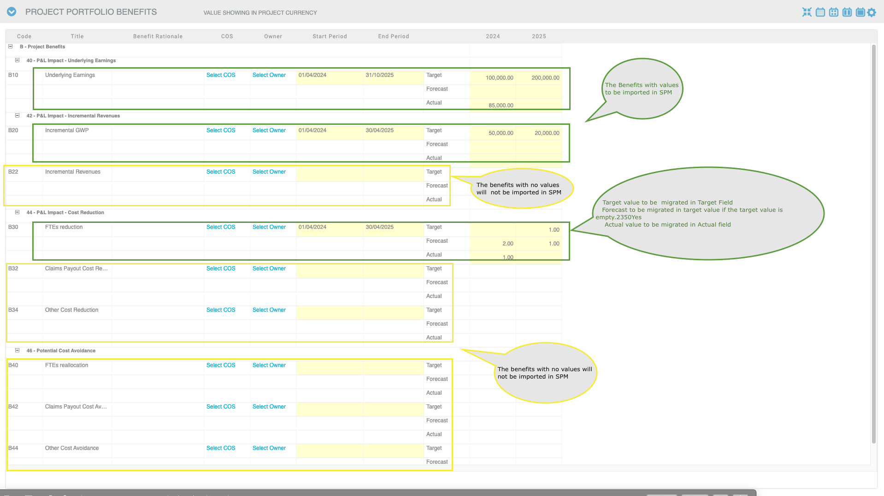

**Value Migration:**

* Validate that target values are migrated to the "Target" field.
* If the "Target" field is empty, ensure that forecast values are migrated to the "Target" field.
* Confirm that actual values are migrated to the "Actual" field.